

Semester One Examination, 2020

Question/Answer booklet

SPECIALIST MATHS
UNIT 3

Section One:

Calculator-free

Your Name

Your Teacher’s Name

Time allowed for this section
Reading time before commencing work: five minutes
Working time: fifty minutes

Materials required/recommended for this section
To be provided by the supervisor
This Question/Answer booklet
Formula sheet

To be provided by the candidate
Standard items: pens (blue/black preferred), pencils (including coloured), sharpener, correction fluid/tape, eraser, ruler, highlighters

Special items: nil

Important note to candidates
No other items may be taken into the examination room. It is your responsibility to ensure that you do not have any unauthorised material. If you have any unauthorised material with you, hand it to the supervisor before reading any further.
Question | Mark | Max | Question | Mark | Max
1 |  |  | 5
2 |  |  | 6
3 |  |  | 7
4

Structure of this paper

Section | Number of questions available | Number of questions to be answered | Working time (minutes) | Marks available | Percentage of examination
Section One:  Calculator-free | 7 | 7 | 50 | 50 | 35
Section Two:  Calculator-assumed | 10 | 10 | 100 | 100 | 65
 |  |  |  | Total | 100

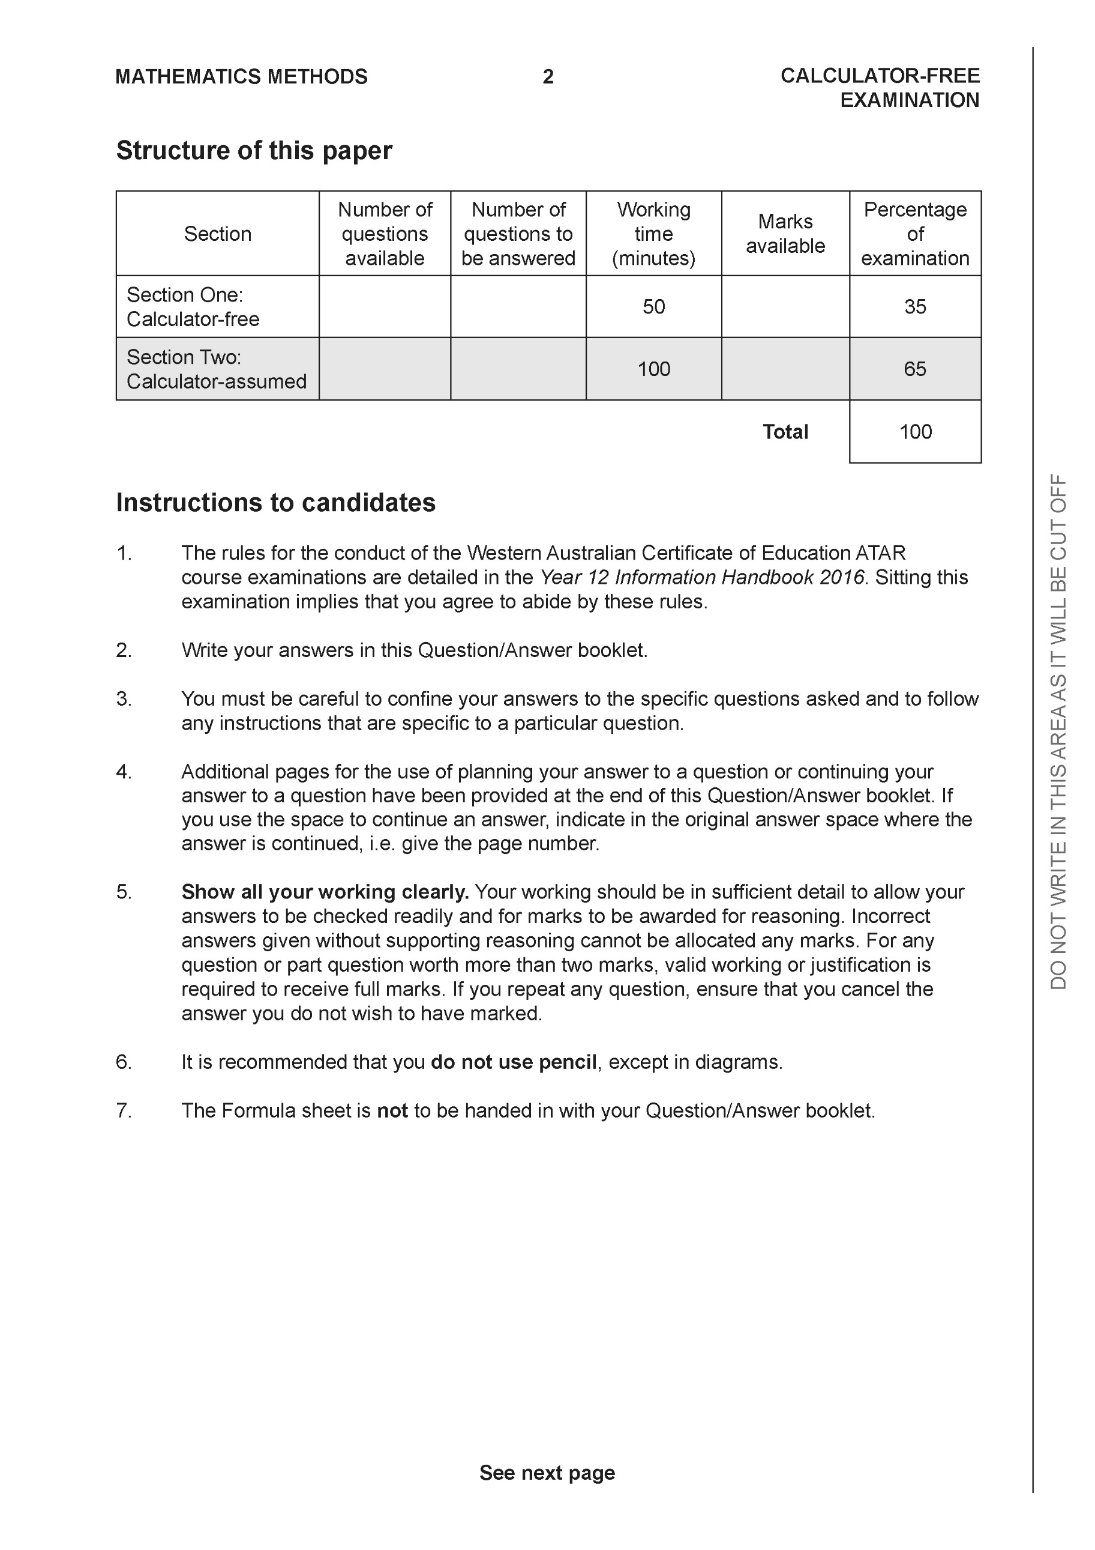

Section One: Calculator-free (50 Marks)

This section has seven (7) questions. Answer all questions. Write your answers in the spaces provided.

Spare pages are included at the end of this booklet. They can be used for planning your responses and/or as additional space if required to continue an answer.
● Planning: If you use the spare pages for planning, indicate this clearly at the top of the page.
● Continuing an answer: If you need to use the space to continue an answer, indicate in the original answer space where the answer is continued, i.e. give the page number. Fill in the number of the question that you are continuing to answer at the top of the page.

Working time: 50 minutes.

Question 1 (6 marks)

Consider the polynomial .
(a) Determine (1 mark)

Solution
Specific behaviours
states zero

(b) Show that is a factor of . (2 marks)

Solution
Specific behaviours
subs correct value for z
shows that all 5 terms cancel to zero (simply stating is not enough)

(c) Determine all the roots to (3 marks)

Solution
Specific behaviours
states real result as one root
uses conjugate
states all four correct roots

Question 2 (10 marks)

Consider the functions & .
- Determine the natural domain and range of . (2 marks)

Solution
Specific behaviours
states domain
states range

- Determine the rule for and state its natural domain and range. (3 marks)

Solution
Specific behaviours
states rule
states natural domain of f
states range

- Determine the rule and natural domain for . Explain why the composite exists. (3 marks)

Solution
Specific behaviours
states un-simplified rules
states domain
shows relevant domain and range and rule for existence

- Does ? Justify. (2 marks)

Solution
No as natural domain is which is different to composite.

Specific behaviours
states no with a reason
correct reason

Question 3 (9 marks)

Consider the function which is drawn below for .

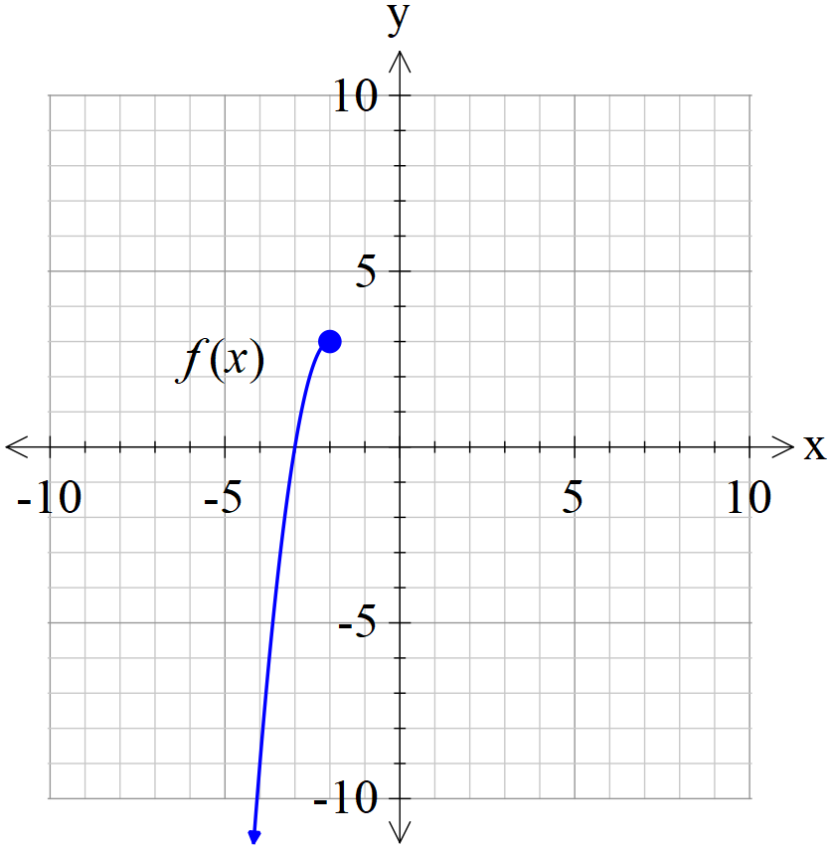

- Sketch on the axes above. (2 marks)
Solution
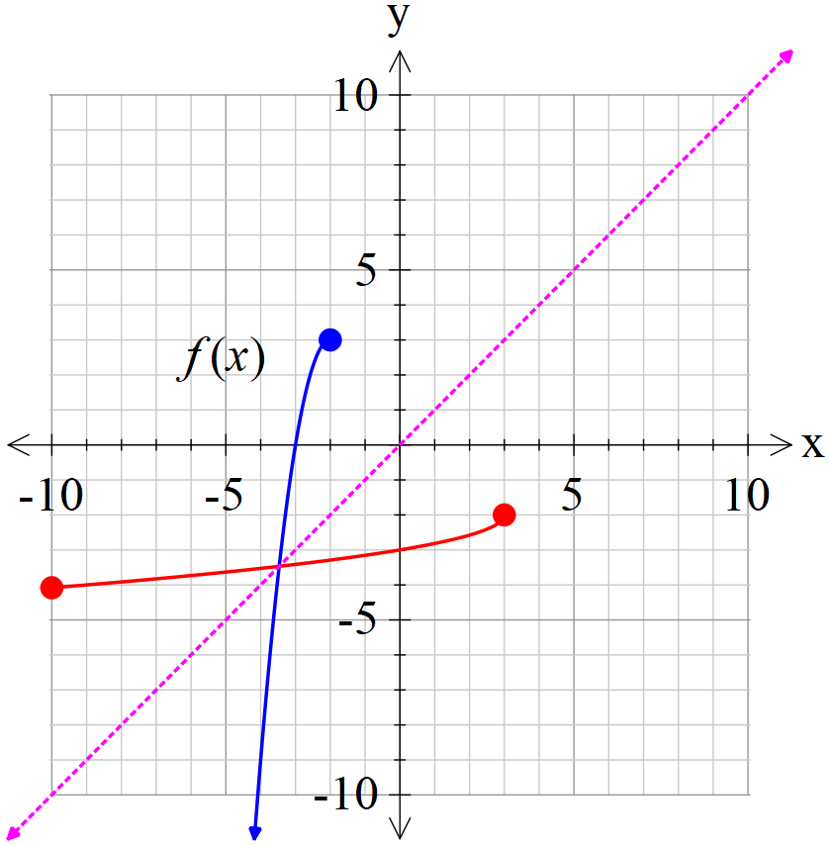

Specific behaviours
appears to be reflected in line y=x
endpoints clearly plotted to scale

- Given that , determine the rule for and state the domain and range. (4 marks)

Solution
Specific behaviours
states domain and range of inverse
swaps x and y
solves for rule with both signs
states correct rule (may be un-simplified)

- Determine the exact solution(s) to if any. (3 marks)

Solution
Specific behaviours
states an equation that will solve for x
solves for x using quadratic formula with working shown
discards the invalid result and states correct exact value (may be un-simplified)

Question 4 (3 marks)

Consider the complex equation for any positive integer . The roots are designated .
Let , determine for any positive integer . Explain.

Solution
Specific behaviours
uses De Moivers
shows that there are n terms with each modulus being
states the required result

Question 5 (5 marks)

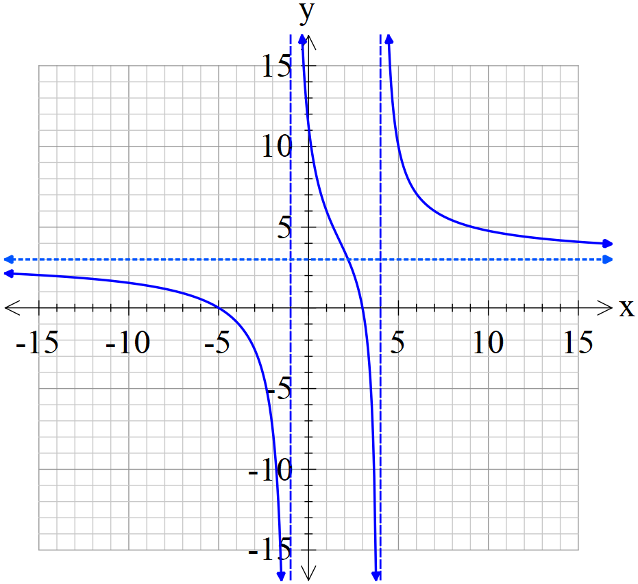 | The function is drawn to the left where are all integers.

Solution
a | b | c | p | q
3 | 6 | -45 | -3 | -4

Specific behaviours
one mark for each correct value

Question 6 (8 marks)

Consider the function which is drawn below and is defined for .

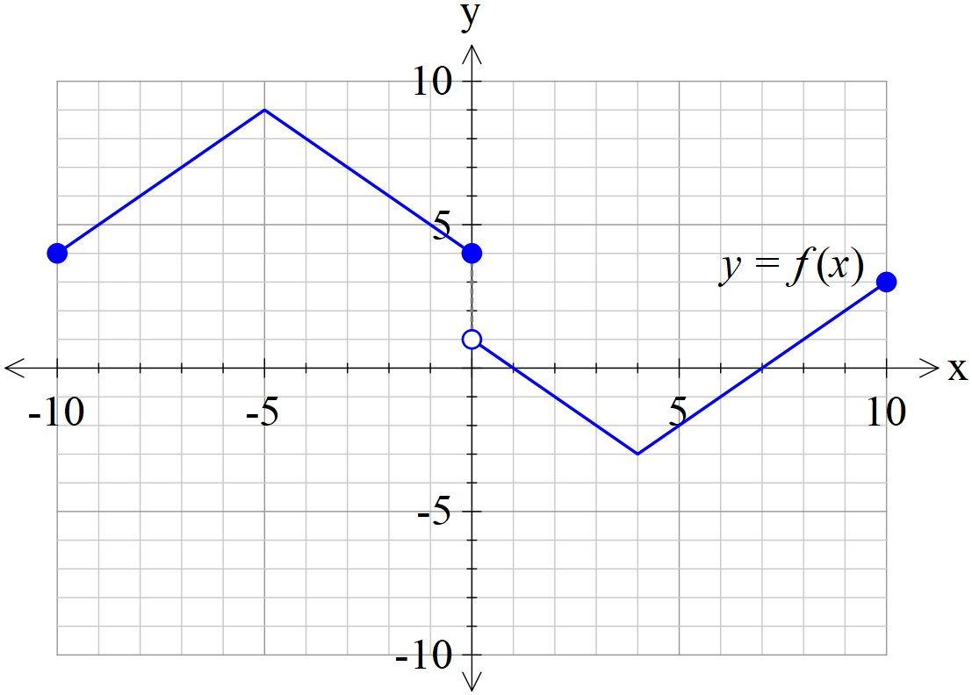

(a) Sketch on the axes below. (2 marks)

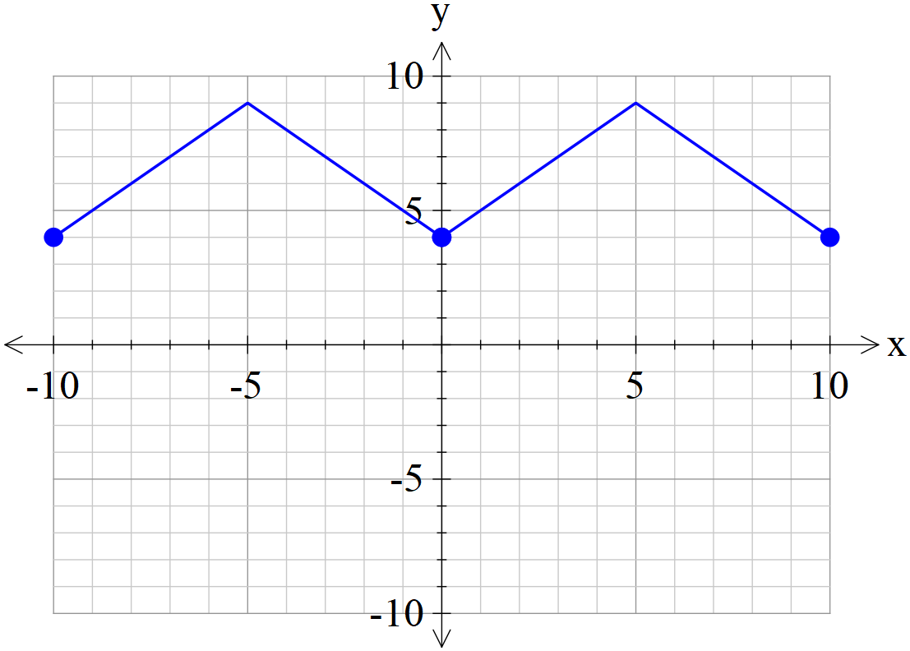 | 1 mark reflects in y axis  1 mark uses left hand side

(b) Sketch on the axes below. (3 marks)

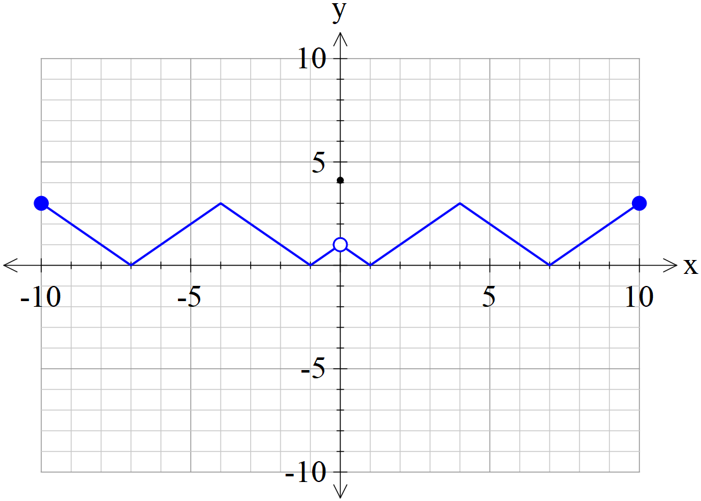 | 1 plots y intercept as 5 only  1 mark uses right hand side  1 mark reflects negative ys in x axis

(c) Sketch on the axes below. (3 marks)

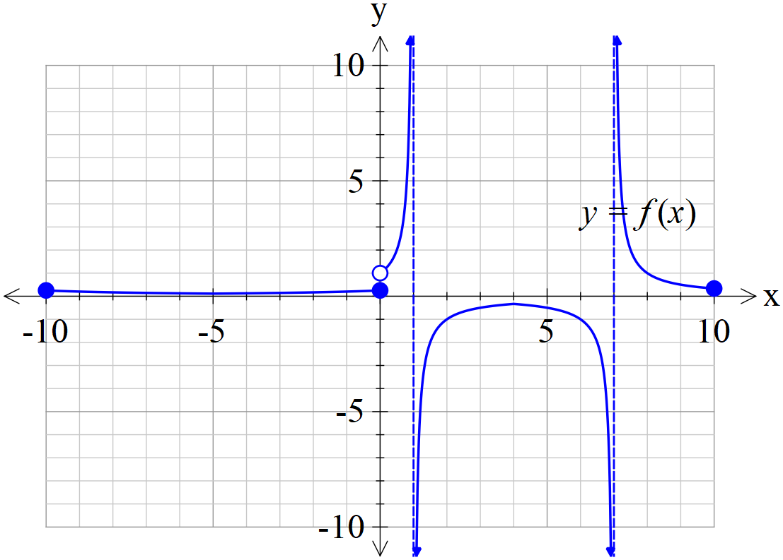 | 1 mark for defined y intercept  1 mark for both vertical asymptotes dotted  1 mark for shape

Question 7 (9 marks)

Consider a projectile that has an initial speed, , at an angle of with the horizontal
that moves with an acceleration of where is a constant.

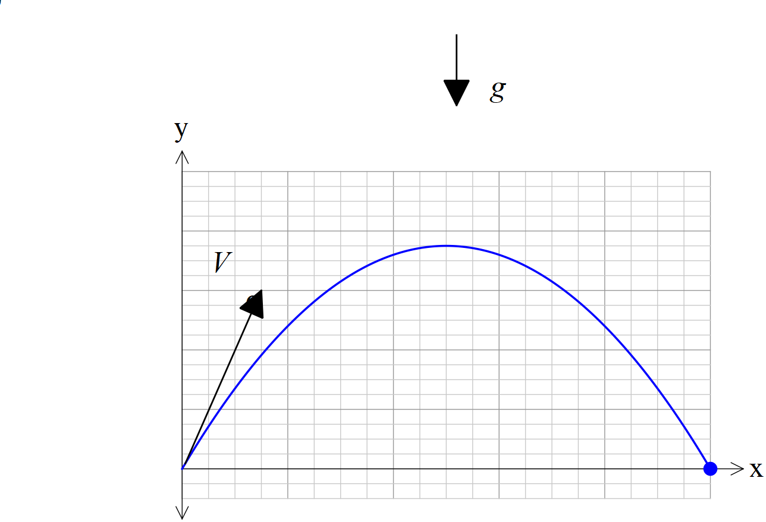

- If the projectile begins at the origin, show that a time, , and using vector calculus that the velocity vector is given by: (2 marks)

Solution
Specific behaviours
determine initial velocity
integrates and solves for vector constant

- In terms of derive the cartesian equation of the projectile. (4 marks)

Solution
Specific behaviours
integrates and shows vector constant
obtains expression for t using x parametric equation
subs t into y parametric equation
derives above equation

- Given that show that is a solution of the following equation.
. (3 marks)

Solution
Specific behaviours
uses secx
uses identity for tan and sec
subs values for V & g

